**Deploy Website on Live Cloud Server**

**Create a website and publish on GIT Hub:**

* Create a new Account of GIT Hup  
  <https://github.com/>
* Signup for new account
* User Name: fullstack-shopping
* Login into your account
* Select the option “Create New Repository”

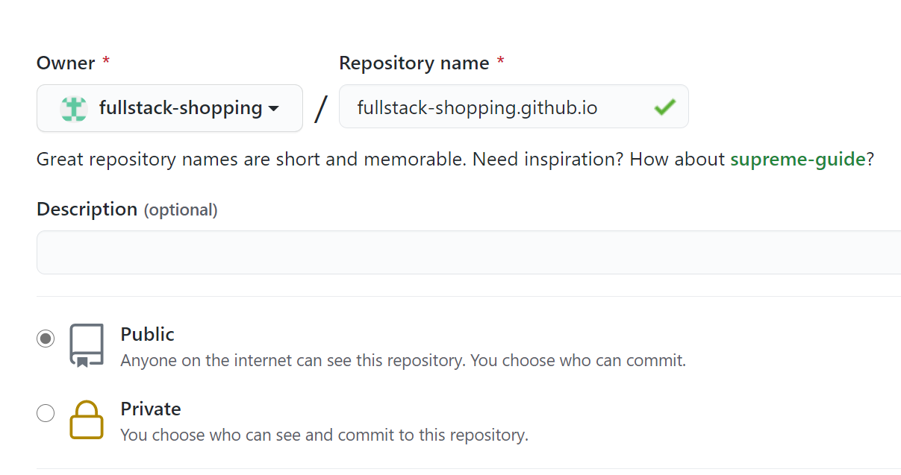

* After repository created: Maintain resources
* Go to your repository and add a new file or upload existing file.
* “Create New File”
* Name: index.html  
  <h2> Full stack – shopping </h2>
* Commit the File
* Test your website from browser  
  <https://fullstack-shopping.github.io/>

**Publishing Resources from local drive**

* Download and Install “Desktop GIT” tool   
  <https://desktop.github.com/>
* Download and Install IDE [Integrated Development Environment]: Visual Studio Code  
  [IDE provides a unified environment from where we can build, debug, test, deploy applications]

<https://code.visualstudio.com/>